# CS 255 System Design Document Template

## UML Diagrams

### UML Use Case Diagram

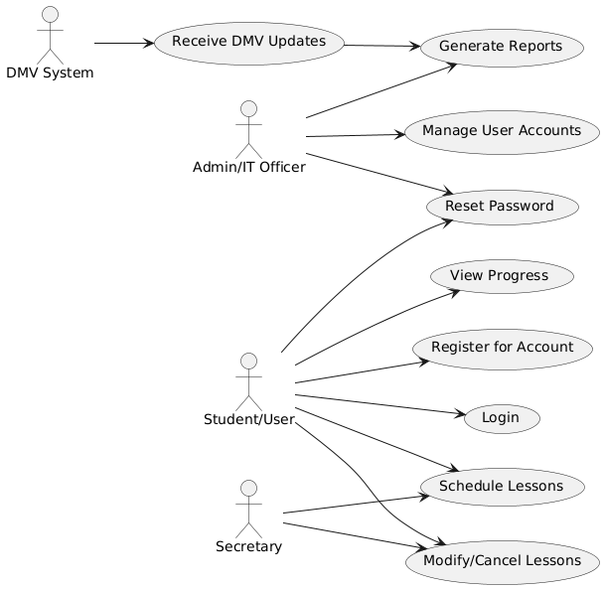

### UML Activity Diagrams

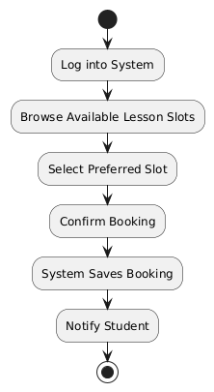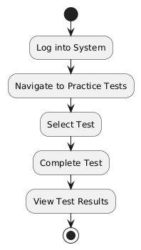

### UML Sequence Diagram

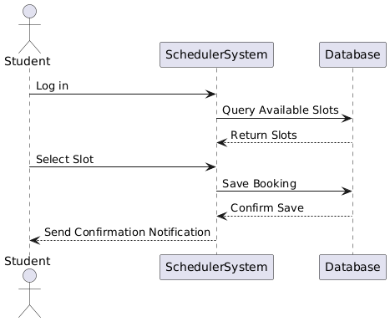

### UML Class Diagram

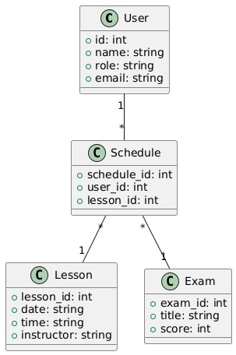

## Technical Requirements

To implement the DriverPass system, the following **technical requirements** have been identified based on the created diagrams and system needs:

#### **Hardware Requirements**

* **Cloud Servers**: The system requires scalable cloud-based servers to store user data, schedules, and driving lesson details securely.
* **Backup Storage**: A secure backup solution to ensure data recovery and redundancy in case of system failures.
* **Workstations/Devices**: Administrators, staff, and students will access the system using desktop, laptop, or mobile devices.

#### **Software Requirements**

* **Web-based Application**: The system will operate as a browser-accessible application for maximum accessibility.
* **Database Management System (DBMS)**: A relational database, such as MySQL or PostgreSQL, will be used to store user accounts, lessons, and test progress data.
* **APIs**: Integration with third-party DMV APIs to receive up-to-date test information.
* **Encryption Libraries**: SSL/TLS for secure data transfers.

#### **Tools**

* **UML Modeling Tools**: Tools like PlantUML or Lucidchart will be used to design and document system diagrams.
* **IDE/Code Editors**: Developers will use tools like Visual Studio Code or IntelliJ for coding and debugging.
* **Version Control**: Git will be used for version management and collaboration among the development team.

#### **Infrastructure**

* **User Authentication**: Multi-factor authentication (MFA) for secure logins.
* **Network Security**: Secure network infrastructure using firewalls and VPNs.
* **Hosting Platform**: The system will be deployed on platforms like AWS, Microsoft Azure, or Google Cloud for scalability and reliability.
* **Backup Strategy**: Daily backups with secure encryption protocols to protect user data.